JRS Website - HR Module
Matched with the latest HR use case diagram
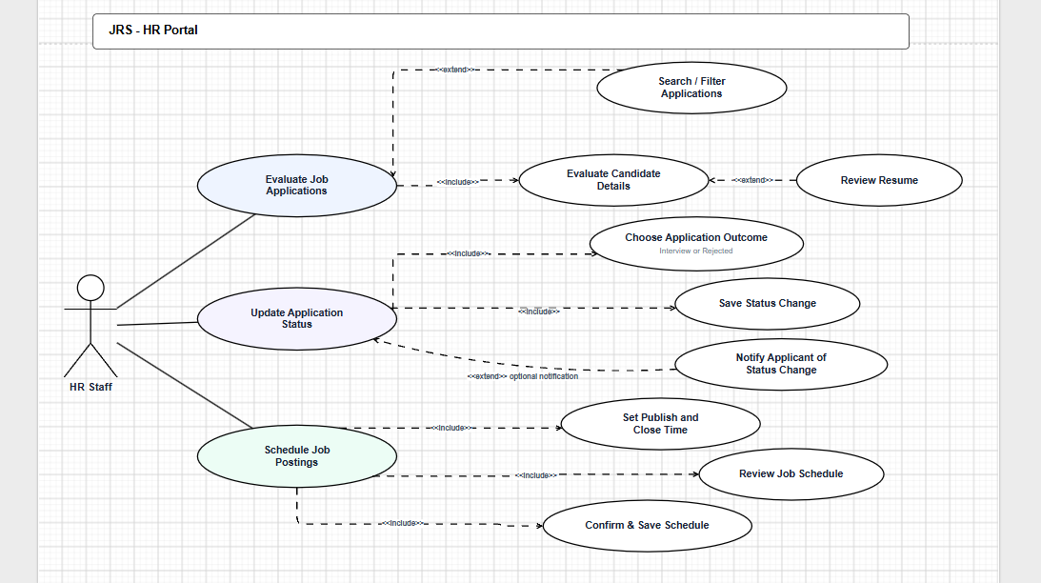
Fully Developed Use Case Description 1
Use case name: | Evaluate Job Applications
Scenario: | HR Staff checks received job applications in the JRS - HR Portal.
Triggering event: | HR Staff opens the application list to evaluate candidates.
Brief description: | HR Staff can search applications, open candidate details, and review resumes before deciding the next step.
Actors: | HR Staff
Related use case: | Search Candidates / Jobs; Evaluate Candidate Details; Review Resume; Update Application Status.
Stakeholders: | HR Staff, HR Department, Job Applicant.
Preconditions: | HR Staff is logged in. Job applications already exist in the system.
Postconditions: | The selected application, candidate details, and resume are reviewed. HR Staff can continue to update the application status.
Flow of activities: | Actor | System
 | 1. HR Staff opens the application list. | 1.1 System displays received job applications.
 | 2. HR Staff searches or filters candidates/jobs if needed. | 2.1 System updates the application list.
 | 3. HR Staff selects one application. | 3.1 System displays the candidate details.
 | 4. HR Staff reviews the resume. | 4.1 System shows resume information for evaluation.
Exception conditions: | 1. No applications are found: System displays an empty list message.  2. Search has no result: System displays “No matching records found.”  3. Candidate details or resume cannot load: System shows an error message.

Fully Developed Use Case Description 2
Use case name: | Update Application Status
Scenario: | HR Staff updates the recruitment status of a selected applicant.
Triggering event: | HR Staff chooses Update Application Status after evaluating an application.
Brief description: | HR Staff selects a new status and saves the change. The system then notifies the applicant of the status change.
Actors: | HR Staff
Related use case: | Select New Status; Save Status Change; Notify Applicant of Status Change.
Stakeholders: | HR Staff, HR Department, Job Applicant.
Preconditions: | HR Staff is logged in. A candidate application has been selected.
Postconditions: | The new application status is saved. The applicant receives a status change notification.
Flow of activities: | Actor | System
 | 1. HR Staff opens Update Application Status. | 1.1 System displays the current applicant and status.
 | 2. HR Staff selects a new status. | 2.1 System checks the selected status.
 | 3. HR Staff saves the status change. | 3.1 System updates the application status.
 | 4. HR Staff confirms notification. | 4.1 System sends the status change notification to the applicant.
Exception conditions: | 1. No new status is selected: System asks HR Staff to select a status.  2. Status cannot be saved: System keeps the old status and shows an error message.  3. Notification fails: System records the failure for retry.

Fully Developed Use Case Description 3
Use case name: | Schedule Job Postings
Scenario: | HR Staff sets when a job posting should be published and closed.
Triggering event: | HR Staff opens the job posting schedule function.
Brief description: | HR Staff sets the publish and close time, evaluates the schedule, and confirms the saved schedule.
Actors: | HR Staff
Related use case: | Set Publish and Close Time; Evaluate Job Schedule; Confirm & Save Schedule.
Stakeholders: | HR Staff, HR Department, Job Applicant.
Preconditions: | HR Staff is logged in. A job posting exists or is being created.
Postconditions: | The job posting schedule is saved. The job can be listed and delisted based on the saved time.
Flow of activities: | Actor | System
 | 1. HR Staff opens Schedule Job Postings. | 1.1 System displays the job schedule form.
 | 2. HR Staff sets publish and close time. | 2.1 System checks that the close time is after the publish time.
 | 3. HR Staff evaluates the job schedule. | 3.1 System displays the schedule summary.
 | 4. HR Staff confirms and saves the schedule. | 4.1 System saves the job posting schedule.
Exception conditions: | 1. Publish or close time is missing: System asks HR Staff to complete the time fields.  2. Close time is earlier than publish time: System shows a validation message.  3. Schedule cannot be saved: System shows an error message.

